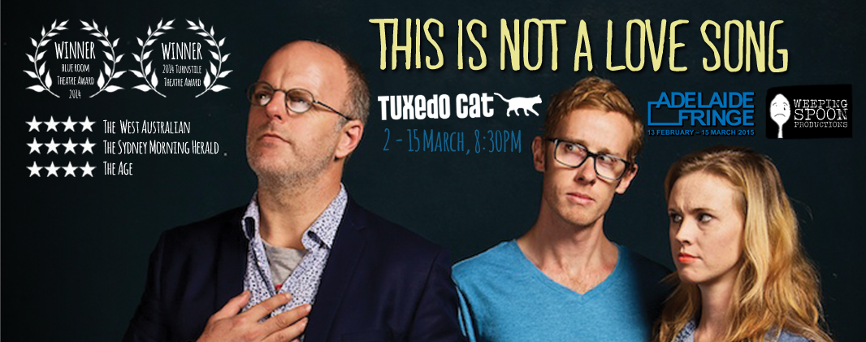

Weeping Spoon Productions Presents
THIS IS NOT A LOVE SONG

Writer: Greg Fleet // Producers: Shane Adamczak, Tegan Mulvany // Director: Tegan Mulvany // Music: Mick Moriarty// Featuring: Shane Adamczak, Greg Fleet, Tegan Mulvany

Falling in love. Falling together. Falling apart.

If there is one thing a comedian knows, it’s how to wreck a relationship. Comic legend Greg Fleet and director Tegan Mulvany team up to present a love story that is equal parts ‘irresistible first kiss’ and ‘unstoppable, hate-fuelled wrecking ball’. This tale is backed by a live soundtrack compiled of every great song ever written*.
We remember everything in a relationship – every smile, kiss and sweet betrayal. But why are my memories so different to yours? Who is that handsome young man you’re with and why are you holding his hand as you listen to our favourite songs?
Let’s be honest. We all know the end of a relationship can be agony, but what hurts more – losing your partner or losing your record collection? As someone once said, “there are no happy endings, just stories that haven’t finished yet”.

WINNER - Blue Room Theatre Award 2014
WINNER - Turnstile Theatre Award 2014
★★★★ -The West Australian
★★★★ -The Age
★★★★ -Sydney Morning Herald

Fresh off the heels of a completely sold out debut season at WA’s The Blue Room and a critically acclaimed run at The Melbourne Fringe, Greg Fleet’s THIS IS NOT A LOVE SONG make’s its SA debut at Tuxedo Cat as part of the 2015 Adelaide Fringe. Following his recent tv series Die On Your Feet and currently writing his autobiography, Greg Fleet, one of Australia’s best known and loved comedians, joins director Tegan Mulvany (The Big HOO-HAA!), performer/Producer Shane Adamczak (Zack Adams and last year’s ★★★★★ Fringe-hit Vicious Circles) and legendary Aussie musician Mick Moriarty (GUD, The Gadflys) on stage for this hilarious, bittersweet tale of love, loss, growing up, growing old and music.

Weeping Spoon Productions is an international multi-award winning independent theatre company based in Perth, Western Australia. Co-founded by a group of professionally trained actors, Weeping Spoon Productions has become one of the most prolific theatre companies in Perth. They have produced several award-winning touring productions including GREED, Love Songs For Future Girl, A Complete History Of Zack Adams, Pollyanna, The Adventures Of Alvin Sputnik and most recently the Sell-out, critically acclaimed shows TRAMPOLINE and BRUCE at The Blue Room Theatre as well as fringe-hit Vicious Circles.

“Greg Fleet’s first theatre play is full of memories, tears, laughter and Good Music… Shane Adamczak is perfect …natural and believable, with comic-dramatic gold … His strong vocal skills work well with the clear sweetness of Tegan Mulvany’s voice as they sing duets. …Not a comedy, but not a kitchen sink drama, either, This is Not a Love Song feels suspiciously autobiographical and peculiarly intimate, providing insights into Greg Fleet’s life and loves, haunting with melodies arranged to tug at the heart strings. “
– Australian Stage
“Audacious, outstanding…marvellous…a run away hit ★★★★” -The West Australian
“Fleet may be best known for his comedy work but here shows solid dramatic skills with loads of presence. It’s an excellent piece of bittersweet theatre” -The Age

VENUE  Tuxedo Cat  54 HYDE ST, ADELAIDE  2 - 15 March, 8:30PM  TICKETS $18-$23  BOOKINGS/INFO adelaidefringe.com.au | PUBLICITY CONTACT  Shane Adamczak  Weeping Spoon Productions  e. shaneadamczak@gmail.com  m. 0439761765  High res images, interviews & comp ticket available upon request  WEEPINGSPOON.COM

*Fact

